Project Idea

**Overview**

Our teams project idea is a mobile application, this application will scan the user’s privacy and security settings on Facebook and other social media platforms to allow the user to be more secure and private. The application will work by the user giving us permission to access their social media accounts, once this access has been granted our server side application will analyse the users social media accounts when directed by the user, once the analysis has been completed the mobile application using push requests will notify the user if their account or accounts are in our opinion not secure or as private as they should be. As social media platforms attempt to minimize how much external applications can access or change via their API’s our application will need to use a combination of API calls and web scraping of the user’s profile to accomplish this task.

For example checking a user’s Facebook account using a combination of web scraping and API calls, our application should be able to determine if a user has posts set to public, pictures publicly available besides the required profile and cover photo, has personally identifiable information shared to the public such as employment details, email address, phone numbers, etc., determine what applications have access to their social media accounts which may pose a security or privacy risk and check for chainmail posts.

Users will then be given access to tutorial videos which will be hosted on our own webserver, which will guide them step by step to correct the security and/or privacy concerns our application has found, these concerns will also be explained to the user in simple terms that the non-technical person can understand.

Additionally, the application will also notify the user of privacy agreement and terms of service changes with their social media accounts registered with our application and supplying the user with more insight on how these changes may affect them or others.

Initially the application will be written to target the privacy and security settings of a user’s Facebook accounts, with the long-term goal of also supporting Twitter, Instagram, WeChat, and others in the future.

**Motivation**

The motivation for this application was to empower users of social media to take back control of their online presence and educate them on the security and privacy issues associated with their use of social media.

Humans are social creatures, and the digital era did not change this, but it did vastly change the way we communicate.

Using social media, we have instant access to billions of people, and we have new ways of interaction. But social media has privacy and security risks, when not used appropriately. It is used also by criminals for fraud, gathering business intelligence, stealing sensitive information, etc. (Tayouri 2015).

The rise of the social web has traditionally been accompanied by privacy concerns (Netter, Herbst & Pernul 2011). Many people may not be aware of how much personally identifiable information about themselves they are sharing online to the public and how secure their various social media accounts are, or how vulnerable they truly are. How a person has their social media accounts security and privacy settings setup makes a substantial difference in determining how much information about them is available to anyone online and how secure their account is in terms of being vulnerable to hacking or other interference or breaches.

Because we are passionate about privacy and security awareness, we wanted to put users back in control of their social media/digital presence and minimize personal data exposure. We believe this application will be useful in achieving that aim.

**Description**

Application

The project is an application for Android and iOS smartphones that will also require external servers for computational purposes. It will check the security and privacy settings of the user's social media accounts, highlight concerns, and make recommendations to improve the safety of their data and personal information. The user will be given links to tutorials demonstrating how to make changes to their settings and navigate the labyrinth of menus purposely designed in a manor to ensure users share as much data as possible by default to allow the company to achieve maximum monetisation. Notifications will be used as the method of keeping users up to date in changes of company policies that affect security and privacy, so they will continue to be protected over time.

Social Media

The Social Media platform the application will initially support will be Facebook, with our intended design, we will be able to incorporate more platforms in the future such as Twitter, Snapchat, LinkedIn, Pinterest, and Reddit among many others.

To authenticate these social media accounts, we will be using each platforms API verification methods to conform to their standards for approval.

The security tokens generated by these APIs will then be encrypted and stored on their device by our application and only be decrypted and supplied to our external applications when requested by the user, once the external applications have completed the tasks they will automatically destroy the copy of the token.

If the user were to delete our application these tokens will be deleted by the mobile application after the mobile application revokes its access to their social media platform accounts, ending our access to their social media platform and personal information.

Security, Privacy and Sharing SettingsUsing a combination of web scraping and Facebook API calls we will be reviewing the user’s entire profile from zero day (Account Creation Day), and checking the privacy settings on every post, image, video and flagging chain/spam posts they have shared. And suggesting changes and deletions.

We will also be checking the privacy settings set on individual profile information such as Work and Education, Places Lived, Contact and Basic Information, Family and Relationships, Details about you and life events.

NOTE: These checks will require the users consent each time, As these checks will not be automatic unless the user schedules these checks, scheduled checks will require the users phone to be online with our application running in the background to allow the API tokens to be decrypted and exchanged with out servers otherwise the task will fail.

Additionally, we will use non-invasive reminders for the user not to use the same password on multiple platforms.

Notifications

There will also be a….

Tutorial Videos

Also included will be...

Innovation

The innovation we would like to see is….

**Tools and Technologies**

[rough notes] @Adam

* Virtual Servers
  + Backend App Processes (Privacy Agreement Checks, Account Reviews, Push Notifications)
  + Webserver Nginx (preferred) / Apache2
  + PostgreSQL or MongoDB database server
  + File Storage
  + AWS for endpoint delivery ONLY
* Android Device (Phone and Tablet or Android Virtual Machine)
* Apple Devices (Phone and Tablet)
* Facebook Developer Account
* Twitter API
* WeChat API & SDK
* Android Studio
* Android SDK
* IOS Software Development Kit
* GitHub or private Git Server
* Open Broadcast Studio – Video Content Creation
* Adobe Premiere
* Adobe Photoshop

The hardware needed to create the project is…. The software we’ll be using is....

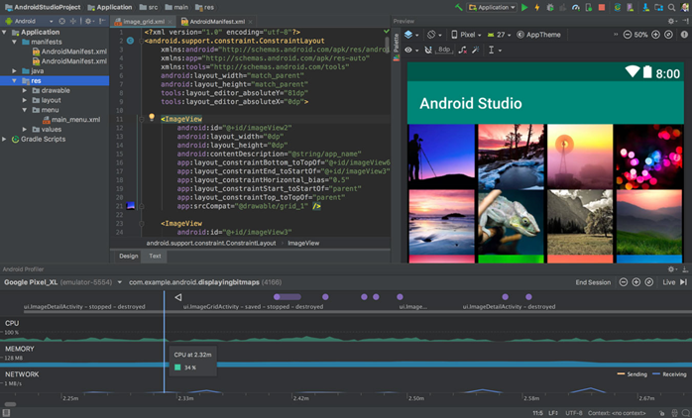

**Skills Required**

The skills required will be/are….. They can be found/learned here…. This project will help us develop our IT skills, experience and knowledge making us more qualified for our ideal jobs than we were before by....

**Outcome**

If our project is successful, the users of our application will have their social media security and privacy settings aligned with their own personal preference and be only sharing what information they deem fit to the appropriate audiences.

Users will be confident that their use of social media is as safe and secure as their social media provider allows and be aware their accounts are as safe as possible from interference and their data and personal information is secure and protected. Hopefully, users will be educated in the risks associated with social media use and the appropriate settings and measures to take place to mitigate those risks, allowing them to enjoy the benefits of social media and avoid the numerous pitfalls.

With our application monitoring for changes that social media platforms may make to any security or privacy practices or practices, users will also be protected into the future and have no need to be anxious about any adverse changes going unnoticed.

The original problem of poor social media security and privacy will be solved, and user's awareness and education will be improved.

The potential drawbacks are the need to have the application running in the background to allow it to provide notifications about setting changes and possibly the need for the application to be updated periodically.

As the application may not be able to make all the changes to a user’s social media account or accounts itself due to the limitations imposed by the social media platforms to their APIs and will have to rely on the user successfully following tutorials, human error may mean some changes may not actually take affect but the user will think they have, lolling them into a false sense of security, however in this case the application will notify the user again, the user may give up making the changes if the task is too laborious or complicated which it sometimes can be when navigating social media security settings - they aren’t always the easiest to locate.

Another potential obstacle we anticipate is keeping up with the changes in a timely manner and having new tutorial videos ready. The tutorial videos must also be easy to follow and aimed at novices which will need testing - the videos could seem easy to follow to ourselves who have IT experience, but we may leave some people behind. We will keep this in mind during development to make sure the app is effective. With appropriate measures and safeguards we believe this application has the potential to make a real difference in improving social media security and privacy, so it can be used safely and be the enjoyable experience it set out to be without the risk.

**References**

Netter, M, Herbst, S & Pernul, G 'Analyzing Privacy in Social Networks – An Interdisciplinary Approach', 9-11 Oct. 2011, pp. 1327-1334.

Tayouri, D 2015, 'The Human Factor in the Social Media Security – Combining Education and Technology to Reduce Social Engineering Risks and Damages', *Procedia Manufacturing*, vol. 3, pp. 1096-1100.